31.49: a)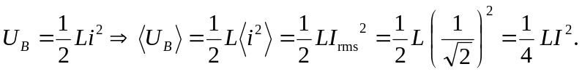
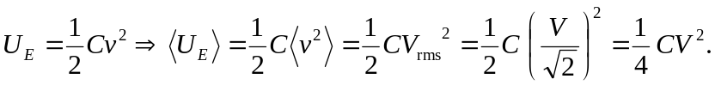
b) Using Problem (31.47a):
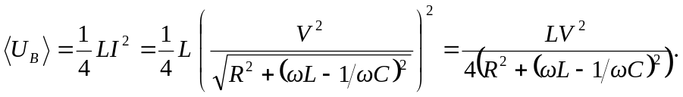
Using Problem (31.47b):
c) Below are the graphs of the magnetic and electric energies, the top two showing the general features, while the bottom two show the details close to angular frequency equal to zero.
d) When the angular frequency is zero, the magnetic energy stored in the inductor is zero, while the electric energy in the capacitor is 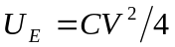. As the frequency goes to infinity, the energy noted in both inductor and capacitor go to zero. The energies equal each other at the resonant frequency where 
